https://www.jb51.net/article/183871.htm

- 将示例中的HuaweiSDK目录拷贝到自己的工程目录下。
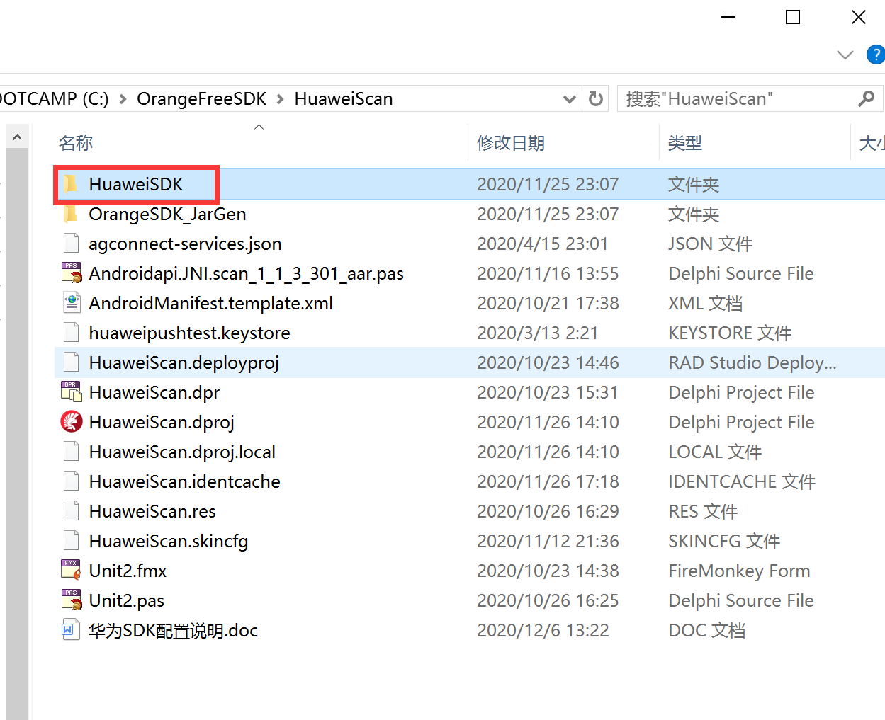

- 打开最新的三方ＳＤＫ布署工具
下载地址：http://www.orangeui.cn/download/sdk/OrangeSDK_SmartDeploy.zip
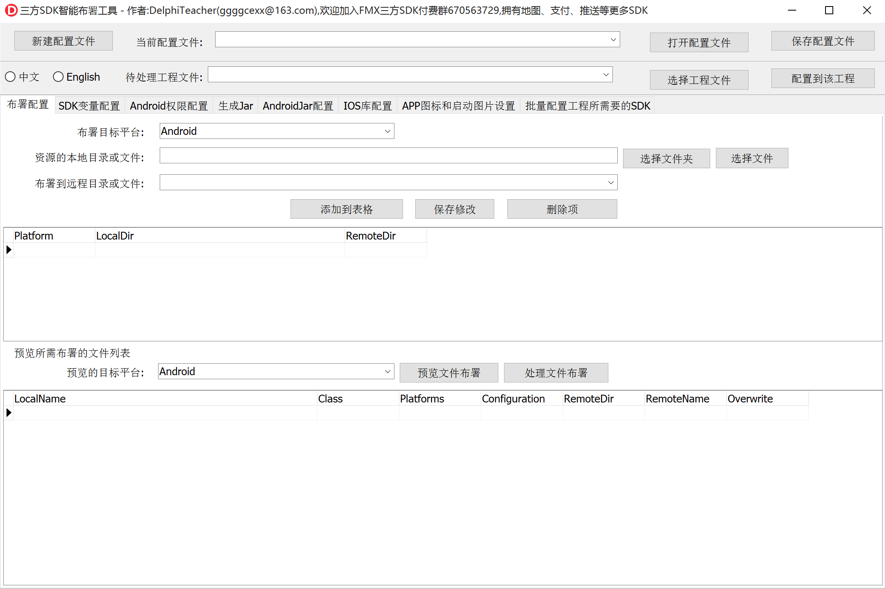
源码地址：
对接的免费三方SDK(华为扫码、苹果扫码等):
https://github.com/DelphiTeacher/OrangeFreeSDK.git

- 关闭工程，用三方ＳＤＫ布署工具打开HuaweiSDK\DeployConfig.ini
接着选择你的工程，
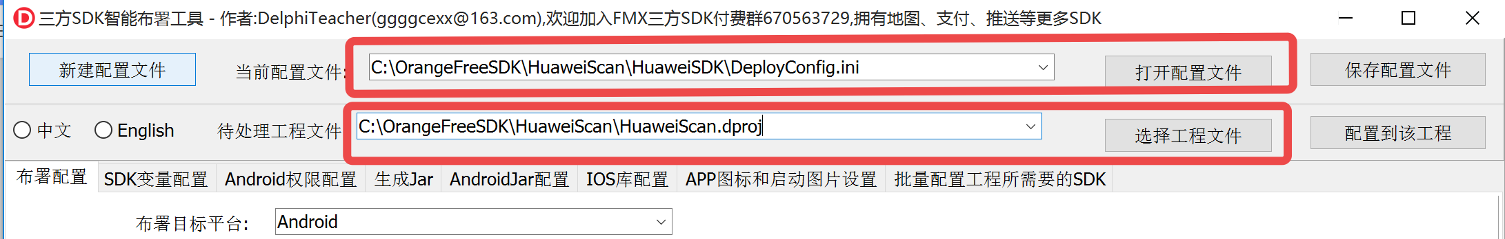
再点击“配置到该工程”按钮即可
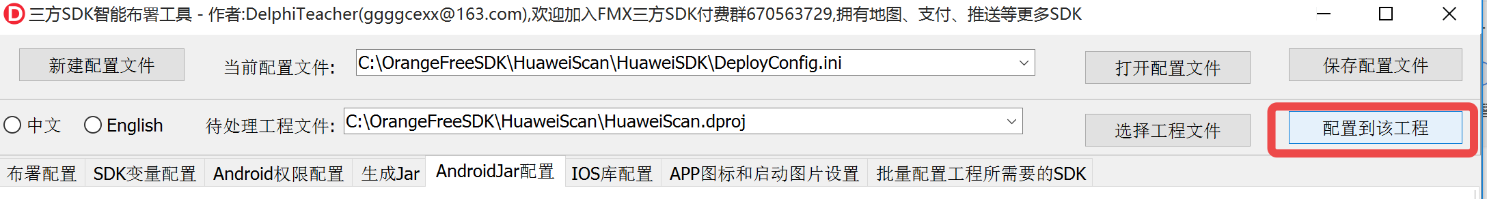

- 先别关这个工具，打开你的工程，编译运行一次，然后在工具中点击“生成R.jar”按钮
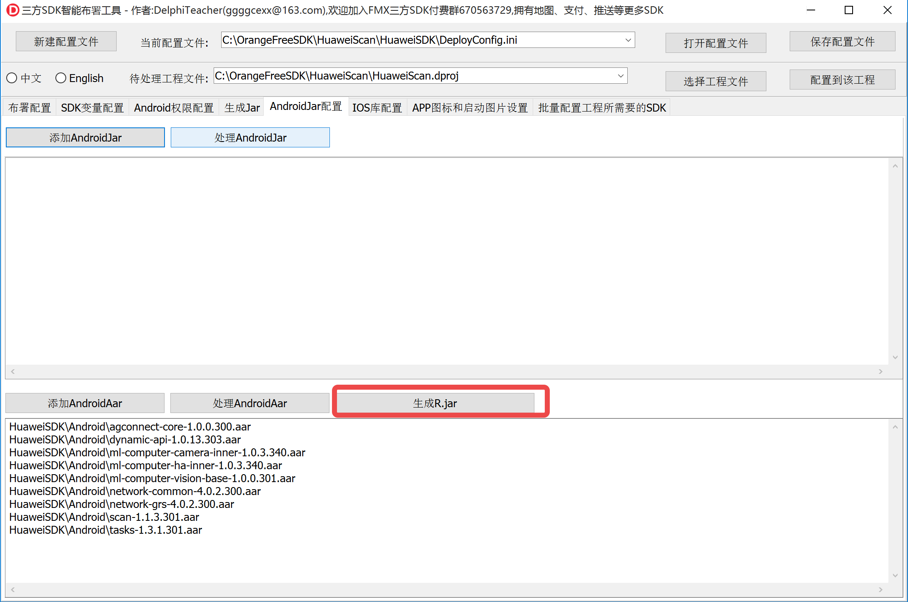
会在工程目录下生成OrangeSDK_JarGen\工程名\R_JAVA_工程名.jar
如示例：OrangeSDK_JarGen\HuaweiScan\R_JAVA_HuaweiScan.jar
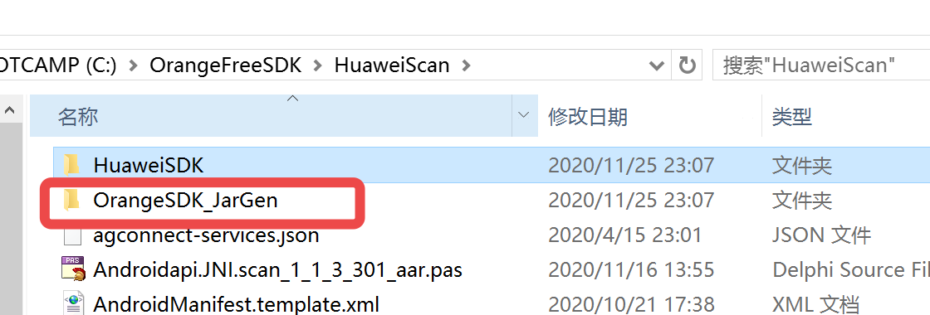
将它添加到工程，再编译运行次即可。

- 完

注意:
- 我是安装了AndroidStudio，编译华为官方扫码的示例，然后将AndroidStudio自动下载的aar拷过来自己对接
- 目前布署工具不能自动布署aar中AndroidManifest.xml中的权限项和组件，所以需要手动布署
- 如果在编译到手机上遇到资源符已经存在，则将资源符删除
- 将华为开发者平台下载你应用的agconnect-services.json布署进去
- 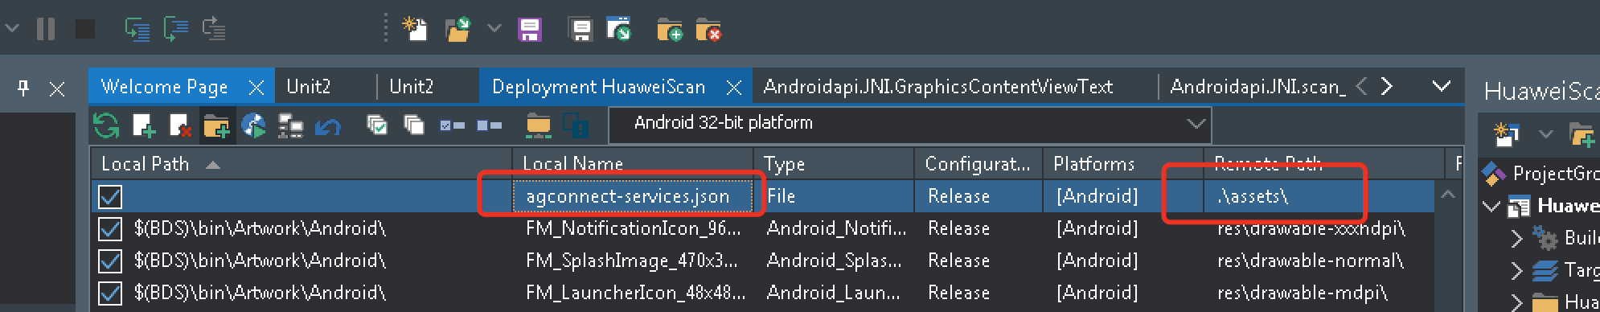
- 运行过一次后，使用三方SDK布署工具处理下aar

从头对接步骤：
- 从华为统一扫码服务官网下载示例，用Android Studio打开，它会自动下载所需要的aar到缓存目录，你所需要的是将这些aar拷出来。
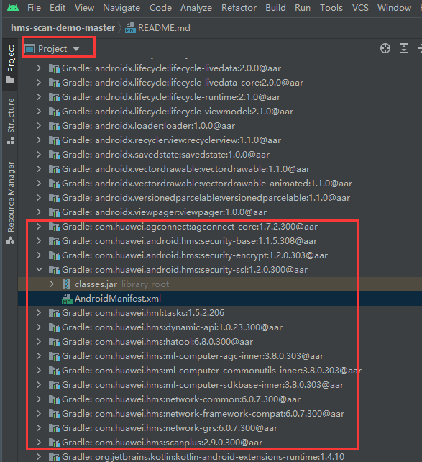
- 用三方工具将这些aar,jar都拷出来，放到SDK目录，并布署到项目中去
- 翻译scan包的Delphi接口单元
- 将aar包中AndroidManifest.xml中的节点权限等拷到项目的AndroidManifest.template.xml中

升级到Delphi 11.1的问题：
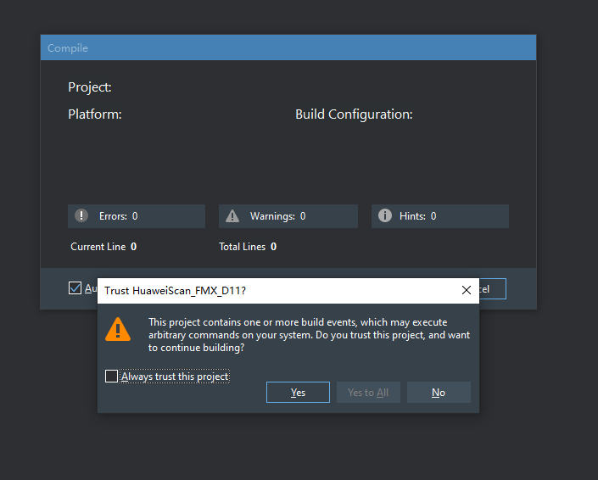
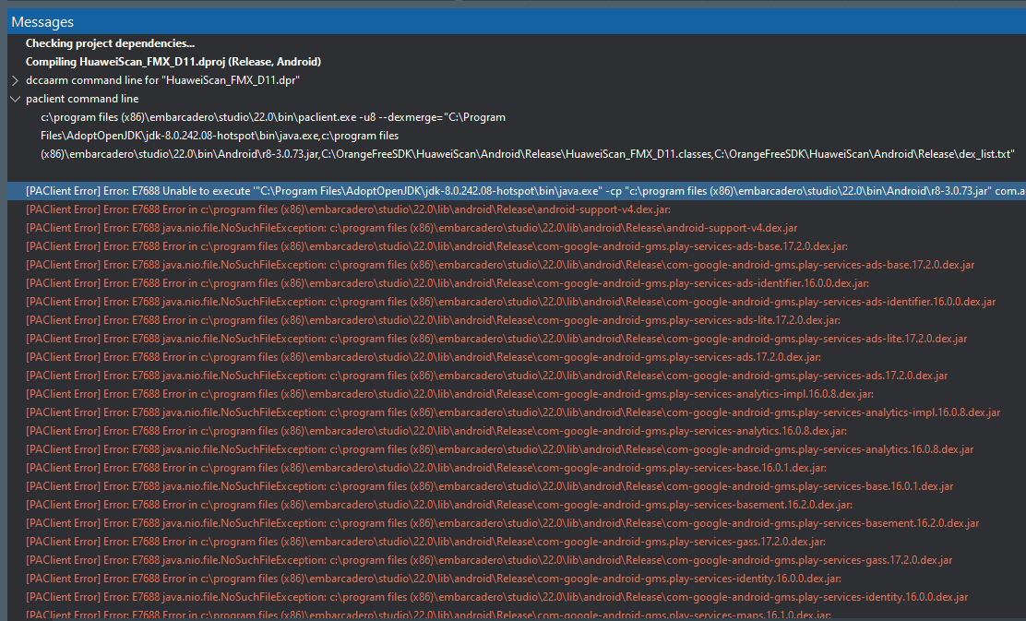
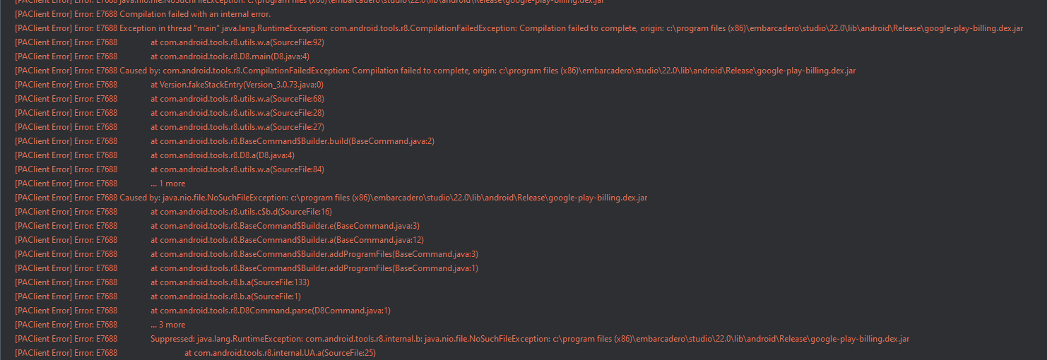
Checking project dependencies...
Compiling HuaweiScan_FMX_D11.dproj (Release, Android)
dccaarm command line for "HuaweiScan_FMX_D11.dpr"
c:\program files (x86)\embarcadero\studio\22.0\bin\dccaarm.exe -$D0 -$L- -$Y- --no-config -M -Q -TX.so
-AGenerics.Collections=System.Generics.Collections;Generics.Defaults=System.Generics.Defaults -DRELEASE;;FRAMEWORK_FMX -E.\Android\Release
-IC:\MyFiles\OrangeProjectCommon;C:\MyFiles\OrangeSDKDesign\DCU\FMX\D10_3\Android\Release;"c:\program files
(x86)\embarcadero\studio\22.0\lib\Android\Release";"C:\三方控件\Devart\UniDAC for RAD Studio 11\Lib\Android32"
-LEC:\Users\Public\Documents\Embarcadero\Studio\22.0\Bpl\Android -LNC:\Users\Public\Documents\Embarcadero\Studio\22.0\Dcp\Android
-NU.\Android\Release -NSSystem;Xml;Data;Datasnap;Web;Soap; -OC:\MyFiles\OrangeProjectCommon;C:\MyFiles\OrangeSDKDesign\DCU\FMX\D10_3\Android\Release;
"c:\program files (x86)\embarcadero\studio\22.0\lib\Android\Release";"C:\三方控件\Devart\UniDAC for RAD Studio 11\Lib\Android32"
-RC:\MyFiles\OrangeProjectCommon;C:\MyFiles\OrangeSDKDesign\DCU\FMX\D10_3\Android\Release;"c:\program files
(x86)\embarcadero\studio\22.0\lib\Android\Release";"C:\三方控件\Devart\UniDAC for RAD Studio 11\Lib\Android32" -UC:\MyFiles\OrangeProjectCommon;
C:\MyFiles\OrangeSDKDesign\DCU\FMX\D10_3\Android\Release;"c:\program files (x86)\embarcadero\studio\22.0\lib\Android\Release";"C:\三方控件\Devart\UniDAC
for RAD Studio 11\Lib\Android32"
--libpath:C:\Users\Public\Documents\Embarcadero\Studio\22.0\PlatformSDKs\android-ndk-r21\platforms\android-23\arch-arm\usr\lib;
C:\Users\Public\Documents\Embarcadero\Studio\22.0\PlatformSDKs\android-ndk-r21\sources\cxx-stl\llvm-libc++\libs\armeabi-v7a
--linker:C:\Users\Public\Documents\Embarcadero\Studio\22.0\PlatformSDKs\android-ndk-r21\toolchains\arm-linux-androideabi-4.9\prebuilt\windows-x86_64\bin\arm-linux-androideabi-ld.exe
-NO.\Android\Release HuaweiScan_FMX_D11.dpr
paclient command line
c:\program files (x86)\embarcadero\studio\22.0\bin\paclient.exe -u8 --dexmerge="C:\Program
Files\AdoptOpenJDK\jdk-8.0.242.08-hotspot\bin\java.exe,c:\program files
(x86)\embarcadero\studio\22.0\bin\Android\r8-3.0.73.jar,C:\OrangeFreeSDK\HuaweiScan\Android\Release\HuaweiScan_FMX_D11.classes,C:\OrangeFreeSDK\HuaweiScan\Android\Release\dex_list.txt"

[PAClient Error] Error: E7688 Unable to execute '"C:\Program Files\AdoptOpenJDK\jdk-8.0.242.08-hotspot\bin\java.exe" -cp "c:\program files (x86)\embarcadero\studio\22.0\bin\Android\r8-3.0.73.jar" com.android.tools.r8.D8 --output "C:\OrangeFreeSDK\HuaweiScan\Android\Release\HuaweiScan_FMX_D11.classes" @"C:\OrangeFreeSDK\HuaweiScan\Android\Release\dex_list.txt"' (Error 1)
[PAClient Error] Error: E7688 Error in c:\program files (x86)\embarcadero\studio\22.0\lib\android\Release\android-support-v4.dex.jar:
[PAClient Error] Error: E7688 java.nio.file.NoSuchFileException: c:\program files (x86)\embarcadero\studio\22.0\lib\android\Release\android-support-v4.dex.jar
[PAClient Error] Error: E7688 Error in c:\program files (x86)\embarcadero\studio\22.0\lib\android\Release\com-google-android-gms.play-services-ads-base.17.2.0.dex.jar:
[PAClient Error] Error: E7688 java.nio.file.NoSuchFileException: c:\program files (x86)\embarcadero\studio\22.0\lib\android\Release\com-google-android-gms.play-services-ads-base.17.2.0.dex.jar
[PAClient Error] Error: E7688 Error in c:\program files (x86)\embarcadero\studio\22.0\lib\android\Release\com-google-android-gms.play-services-ads-identifier.16.0.0.dex.jar:
[PAClient Error] Error: E7688 java.nio.file.NoSuchFileException: c:\program files (x86)\embarcadero\studio\22.0\lib\android\Release\com-google-android-gms.play-services-ads-identifier.16.0.0.dex.jar
[PAClient Error] Error: E7688 Error in c:\program files (x86)\embarcadero\studio\22.0\lib\android\Release\com-google-android-gms.play-services-ads-lite.17.2.0.dex.jar:
[PAClient Error] Error: E7688 java.nio.file.NoSuchFileException: c:\program files (x86)\embarcadero\studio\22.0\lib\android\Release\com-google-android-gms.play-services-ads-lite.17.2.0.dex.jar
[PAClient Error] Error: E7688 Error in c:\program files (x86)\embarcadero\studio\22.0\lib\android\Release\com-google-android-gms.play-services-ads.17.2.0.dex.jar:
[PAClient Error] Error: E7688 java.nio.file.NoSuchFileException: c:\program files (x86)\embarcadero\studio\22.0\lib\android\Release\com-google-android-gms.play-services-ads.17.2.0.dex.jar
[PAClient Error] Error: E7688 Error in c:\program files (x86)\embarcadero\studio\22.0\lib\android\Release\com-google-android-gms.play-services-analytics-impl.16.0.8.dex.jar:
[PAClient Error] Error: E7688 java.nio.file.NoSuchFileException: c:\program files (x86)\embarcadero\studio\22.0\lib\android\Release\com-google-android-gms.play-services-analytics-impl.16.0.8.dex.jar
[PAClient Error] Error: E7688 Error in c:\program files (x86)\embarcadero\studio\22.0\lib\android\Release\com-google-android-gms.play-services-analytics.16.0.8.dex.jar:
[PAClient Error] Error: E7688 java.nio.file.NoSuchFileException: c:\program files (x86)\embarcadero\studio\22.0\lib\android\Release\com-google-android-gms.play-services-analytics.16.0.8.dex.jar
[PAClient Error] Error: E7688 Error in c:\program files (x86)\embarcadero\studio\22.0\lib\android\Release\com-google-android-gms.play-services-base.16.0.1.dex.jar:
[PAClient Error] Error: E7688 java.nio.file.NoSuchFileException: c:\program files (x86)\embarcadero\studio\22.0\lib\android\Release\com-google-android-gms.play-services-base.16.0.1.dex.jar
[PAClient Error] Error: E7688 Error in c:\program files (x86)\embarcadero\studio\22.0\lib\android\Release\com-google-android-gms.play-services-basement.16.2.0.dex.jar:
[PAClient Error] Error: E7688 java.nio.file.NoSuchFileException: c:\program files (x86)\embarcadero\studio\22.0\lib\android\Release\com-google-android-gms.play-services-basement.16.2.0.dex.jar
[PAClient Error] Error: E7688 Error in c:\program files (x86)\embarcadero\studio\22.0\lib\android\Release\com-google-android-gms.play-services-gass.17.2.0.dex.jar:
[PAClient Error] Error: E7688 java.nio.file.NoSuchFileException: c:\program files (x86)\embarcadero\studio\22.0\lib\android\Release\com-google-android-gms.play-services-gass.17.2.0.dex.jar
[PAClient Error] Error: E7688 Error in c:\program files (x86)\embarcadero\studio\22.0\lib\android\Release\com-google-android-gms.play-services-identity.16.0.0.dex.jar:
[PAClient Error] Error: E7688 java.nio.file.NoSuchFileException: c:\program files (x86)\embarcadero\studio\22.0\lib\android\Release\com-google-android-gms.play-services-identity.16.0.0.dex.jar
[PAClient Error] Error: E7688 Error in c:\program files (x86)\embarcadero\studio\22.0\lib\android\Release\com-google-android-gms.play-services-maps.16.1.0.dex.jar:
[PAClient Error] Error: E7688 java.nio.file.NoSuchFileException: c:\program files (x86)\embarcadero\studio\22.0\lib\android\Release\com-google-android-gms.play-services-maps.16.1.0.dex.jar
[PAClient Error] Error: E7688 Error in c:\program files (x86)\embarcadero\studio\22.0\lib\android\Release\com-google-android-gms.play-services-measurement-base.16.4.0.dex.jar:
[PAClient Error] Error: E7688 java.nio.file.NoSuchFileException: c:\program files (x86)\embarcadero\studio\22.0\lib\android\Release\com-google-android-gms.play-services-measurement-base.16.4.0.dex.jar
[PAClient Error] Error: E7688 Error in c:\program files (x86)\embarcadero\studio\22.0\lib\android\Release\com-google-android-gms.play-services-measurement-sdk-api.16.4.0.dex.jar:
[PAClient Error] Error: E7688 java.nio.file.NoSuchFileException: c:\program files (x86)\embarcadero\studio\22.0\lib\android\Release\com-google-android-gms.play-services-measurement-sdk-api.16.4.0.dex.jar
[PAClient Error] Error: E7688 Error in c:\program files (x86)\embarcadero\studio\22.0\lib\android\Release\com-google-android-gms.play-services-stats.16.0.1.dex.jar:
[PAClient Error] Error: E7688 java.nio.file.NoSuchFileException: c:\program files (x86)\embarcadero\studio\22.0\lib\android\Release\com-google-android-gms.play-services-stats.16.0.1.dex.jar
[PAClient Error] Error: E7688 Error in c:\program files (x86)\embarcadero\studio\22.0\lib\android\Release\com-google-android-gms.play-services-tagmanager-v4-impl.16.0.8.dex.jar:
[PAClient Error] Error: E7688 java.nio.file.NoSuchFileException: c:\program files (x86)\embarcadero\studio\22.0\lib\android\Release\com-google-android-gms.play-services-tagmanager-v4-impl.16.0.8.dex.jar
[PAClient Error] Error: E7688 Error in c:\program files (x86)\embarcadero\studio\22.0\lib\android\Release\com-google-android-gms.play-services-tasks.16.0.1.dex.jar:
[PAClient Error] Error: E7688 java.nio.file.NoSuchFileException: c:\program files (x86)\embarcadero\studio\22.0\lib\android\Release\com-google-android-gms.play-services-tasks.16.0.1.dex.jar
[PAClient Error] Error: E7688 Error in c:\program files (x86)\embarcadero\studio\22.0\lib\android\Release\com-google-android-gms.play-services-wallet.16.0.1.dex.jar:
[PAClient Error] Error: E7688 java.nio.file.NoSuchFileException: c:\program files (x86)\embarcadero\studio\22.0\lib\android\Release\com-google-android-gms.play-services-wallet.16.0.1.dex.jar
[PAClient Error] Error: E7688 Error in c:\program files (x86)\embarcadero\studio\22.0\lib\android\Release\com-google-firebase.firebase-analytics.16.4.0.dex.jar:
[PAClient Error] Error: E7688 java.nio.file.NoSuchFileException: c:\program files (x86)\embarcadero\studio\22.0\lib\android\Release\com-google-firebase.firebase-analytics.16.4.0.dex.jar
[PAClient Error] Error: E7688 Error in c:\program files (x86)\embarcadero\studio\22.0\lib\android\Release\com-google-firebase.firebase-common.16.1.0.dex.jar:
[PAClient Error] Error: E7688 java.nio.file.NoSuchFileException: c:\program files (x86)\embarcadero\studio\22.0\lib\android\Release\com-google-firebase.firebase-common.16.1.0.dex.jar
[PAClient Error] Error: E7688 Error in c:\program files (x86)\embarcadero\studio\22.0\lib\android\Release\com-google-firebase.firebase-iid-interop.16.0.1.dex.jar:
[PAClient Error] Error: E7688 java.nio.file.NoSuchFileException: c:\program files (x86)\embarcadero\studio\22.0\lib\android\Release\com-google-firebase.firebase-iid-interop.16.0.1.dex.jar
[PAClient Error] Error: E7688 Error in c:\program files (x86)\embarcadero\studio\22.0\lib\android\Release\com-google-firebase.firebase-iid.17.1.1.dex.jar:
[PAClient Error] Error: E7688 java.nio.file.NoSuchFileException: c:\program files (x86)\embarcadero\studio\22.0\lib\android\Release\com-google-firebase.firebase-iid.17.1.1.dex.jar
[PAClient Error] Error: E7688 Error in c:\program files (x86)\embarcadero\studio\22.0\lib\android\Release\com-google-firebase.firebase-measurement-connector.17.0.1.dex.jar:
[PAClient Error] Error: E7688 java.nio.file.NoSuchFileException: c:\program files (x86)\embarcadero\studio\22.0\lib\android\Release\com-google-firebase.firebase-measurement-connector.17.0.1.dex.jar
[PAClient Error] Error: E7688 Error in c:\program files (x86)\embarcadero\studio\22.0\lib\android\Release\com-google-firebase.firebase-messaging.17.5.0.dex.jar:
[PAClient Error] Error: E7688 java.nio.file.NoSuchFileException: c:\program files (x86)\embarcadero\studio\22.0\lib\android\Release\com-google-firebase.firebase-messaging.17.5.0.dex.jar
[PAClient Error] Error: E7688 Error in c:\program files (x86)\embarcadero\studio\22.0\lib\android\Release\google-play-billing.dex.jar:
[PAClient Error] Error: E7688 java.nio.file.NoSuchFileException: c:\program files (x86)\embarcadero\studio\22.0\lib\android\Release\google-play-billing.dex.jar
[PAClient Error] Error: E7688 Compilation failed with an internal error.
[PAClient Error] Error: E7688 Exception in thread "main" java.lang.RuntimeException: com.android.tools.r8.CompilationFailedException: Compilation failed to complete, origin: c:\program files (x86)\embarcadero\studio\22.0\lib\android\Release\google-play-billing.dex.jar
[PAClient Error] Error: E7688 at com.android.tools.r8.utils.w.a(SourceFile:92)
[PAClient Error] Error: E7688 at com.android.tools.r8.D8.main(D8.java:4)
[PAClient Error] Error: E7688 Caused by: com.android.tools.r8.CompilationFailedException: Compilation failed to complete, origin: c:\program files (x86)\embarcadero\studio\22.0\lib\android\Release\google-play-billing.dex.jar
[PAClient Error] Error: E7688 at Version.fakeStackEntry(Version_3.0.73.java:0)
[PAClient Error] Error: E7688 at com.android.tools.r8.utils.w.a(SourceFile:68)
[PAClient Error] Error: E7688 at com.android.tools.r8.utils.w.a(SourceFile:28)
[PAClient Error] Error: E7688 at com.android.tools.r8.utils.w.a(SourceFile:27)
[PAClient Error] Error: E7688 at com.android.tools.r8.BaseCommand$Builder.build(BaseCommand.java:2)
[PAClient Error] Error: E7688 at com.android.tools.r8.D8.a(D8.java:4)
[PAClient Error] Error: E7688 at com.android.tools.r8.utils.w.a(SourceFile:84)
[PAClient Error] Error: E7688 ... 1 more
[PAClient Error] Error: E7688 Caused by: java.nio.file.NoSuchFileException: c:\program files (x86)\embarcadero\studio\22.0\lib\android\Release\google-play-billing.dex.jar
[PAClient Error] Error: E7688 at com.android.tools.r8.utils.c$b.d(SourceFile:16)
[PAClient Error] Error: E7688 at com.android.tools.r8.BaseCommand$Builder.e(BaseCommand.java:3)
[PAClient Error] Error: E7688 at com.android.tools.r8.BaseCommand$Builder.a(BaseCommand.java:12)
[PAClient Error] Error: E7688 at com.android.tools.r8.BaseCommand$Builder.addProgramFiles(BaseCommand.java:3)
[PAClient Error] Error: E7688 at com.android.tools.r8.BaseCommand$Builder.addProgramFiles(BaseCommand.java:1)
[PAClient Error] Error: E7688 at com.android.tools.r8.b.a(SourceFile:133)
[PAClient Error] Error: E7688 at com.android.tools.r8.b.a(SourceFile:1)
[PAClient Error] Error: E7688 at com.android.tools.r8.D8Command.parse(D8Command.java:1)
[PAClient Error] Error: E7688 ... 3 more
[PAClient Error] Error: E7688 Suppressed: java.lang.RuntimeException: com.android.tools.r8.internal.b: java.nio.file.NoSuchFileException: c:\program files (x86)\embarcadero\studio\22.0\lib\android\Release\google-play-billing.dex.jar
[PAClient Error] Error: E7688 at com.android.tools.r8.internal.UA.a(SourceFile:25)
[PAClient Error] Error: E7688 at com.android.tools.r8.BaseCommand$Builder.a(BaseCommand.java:3)
[PAClient Error] Error: E7688 at com.android.tools.r8.utils.w.a(SourceFile:24)
[PAClient Error] Error: E7688 at com.android.tools.r8.BaseCommand$Builder.build(BaseCommand.java:2)
[PAClient Error] Error: E7688 ... 3 more
[PAClient Error] Error: E7688 Caused by: com.android.tools.r8.internal.b: java.nio.file.NoSuchFileException: c:\program files (x86)\embarcadero\studio\22.0\lib\android\Release\google-play-billing.dex.jar
[PAClient Error] Error: E7688 at com.android.tools.r8.internal.UA.a(SourceFile:14)
[PAClient Error] Error: E7688 at com.android.tools.r8.internal.UA.error(SourceFile:1)
[PAClient Error] Error: E7688 at com.android.tools.r8.utils.c$b.d(SourceFile:17)
[PAClient Error] Error: E7688 at com.android.tools.r8.BaseCommand$Builder.e(BaseCommand.java:3)
[PAClient Error] Error: E7688 at com.android.tools.r8.BaseCommand$Builder.a(BaseCommand.java:12)
[PAClient Error] Error: E7688 at com.android.tools.r8.BaseCommand$Builder.addProgramFiles(BaseCommand.java:3)
[PAClient Error] Error: E7688 at com.android.tools.r8.BaseCommand$Builder.addProgramFiles(BaseCommand.java:1)
[PAClient Error] Error: E7688 at com.android.tools.r8.b.a(SourceFile:133)
[PAClient Error] Error: E7688 at com.android.tools.r8.b.a(SourceFile:1)
[PAClient Error] Error: E7688 at com.android.tools.r8.D8Command.parse(D8Command.java:1)
[PAClient Error] Error: E7688 ... 3 more
[PAClient Error] Error: E7688 [CIRCULAR REFERENCE:java.nio.file.NoSuchFileException: c:\program files (x86)\embarcadero\studio\22.0\lib\android\Release\google-play-billing.dex.jar]
Failed
Elapsed time: 00:00:04.2

[PAClient Error] Error: E7688 [CIRCULAR REFERENCE:java.nio.file.NoSuchFileException: c:\program files (x86)\embarcadero\studio\22.0\lib\android\Release\google-play-billing.dex.jar]

jar需要revert to system default
重新生成R.jar
运行闪退
跟踪日志

06-13 14:57:29.303 32537 32537 F DEBUG : *** *** *** *** *** *** *** *** *** *** *** *** *** *** *** ***
06-13 14:57:29.303 32537 32537 F DEBUG : Build fingerprint: 'Xiaomi/laurus/laurus:10/QKQ1.190910.002/V12.5.5.0.QFMCNXM:user/release-keys'
06-13 14:57:29.303 32537 32537 F DEBUG : Revision: '0'
06-13 14:57:29.303 32537 32537 F DEBUG : ABI: 'arm'
06-13 14:57:29.304 32537 32537 F DEBUG : Timestamp: 2022-06-13 14:57:29+0800
06-13 14:57:29.304 32537 32537 F DEBUG : pid: 32353, tid: 32353, name: .huaweipushtest >>> com.ggggcexx.huaweipushtest <<<
06-13 14:57:29.304 32537 32537 F DEBUG : uid: 10728
06-13 14:57:29.304 32537 32537 F DEBUG : signal 6 (SIGABRT), code -1 (SI_QUEUE), fault addr --------
06-13 14:57:29.304 32537 32537 F DEBUG : Abort message: 'JNI DETECTED ERROR IN APPLICATION: JNI RegisterNatives called with pending exception java.lang.NoSuchMethodError: no static or non-static method "Lcom/embarcadero/rtl/ProxyInterface;.dispatchToNative2(Ljava/lang/String;Ljava/lang/String;[Ljava/lang/Object;J)Ljava/lang/Object;"
06-13 14:57:29.304 32537 32537 F DEBUG : at long android.app.NativeActivity.loadNativeCode(java.lang.String, java.lang.String, android.os.MessageQueue, java.lang.String, java.lang.String, java.lang.String, int, android.content.res.AssetManager, byte[], java.lang.ClassLoader, java.lang.String) (NativeActivity.java:-2)
06-13 14:57:29.304 32537 32537 F DEBUG : at void android.app.NativeActivity.onCreate(android.os.Bundle) (NativeActivity.java:170)
06-13 14:57:29.304 32537 32537 F DEBUG : at void com.embarcadero.firemonkey.FMXNativeActivity.onCreate(android.os.Bundle) (FMXNativeActivity.java:135)
06-13 14:57:29.304 32537 32537 F DEBUG : at void android.app.Activity.performCreate(android.os.Bundle, android.os.PersistableBundle) (Activity.java:7893)
06-13 14:57:29.304 32537 32537 F DEBUG : at void android.app.Activity.performCreate(android.os.Bundle) (Activity.java:7880)
06-13 14:57:29.304 32537 32537 F DEBUG : at void android.app.Instrumentation.callActivityOnCreate(android.app.Activity, android.os.Bundle) (Instrumentation.java:1307)
06-13 14:57:29.304 32537 32537 F DEBUG : at android.app.Activity android.app.ActivityThread.performLaunchActivity(android.app.ActivityThread$ActivityClientRecord, android.content.Intent) (ActivityThread.java:3281)
06-13 14:57:29.304 32537 32537 F DEBUG : at android.app.Activity android.app.ActivityThread.handleLaunchActivity(android.app.ActivityThread$ActivityClientRecord, android.app.servertransaction.PendingTransactionActions, android.content.Intent) (ActivityThread.java:3455)
06-13 14:57:29.304 32537 32537 F DEBUG : at void android.app.servertransaction.LaunchActivityItem.execute(android.app.ClientTransactionHandler, android.os.IBinder, android.app.servertransaction.PendingTransactionActions) (LaunchActivityItem.java:83)
06-13 14:57:29.304 32537 32537 F DEBUG : at void android.app.servertransaction.TransactionExecutor.executeCallbacks(android.app.servertransaction.ClientTransaction) (TransactionExecutor.java:135)
06-13 14:57:29.304 32537 32537 F DEBUG : at void android.app.servertransaction.TransactionExecutor.execute(android.app.servertransaction.ClientTransaction) (TransactionExecutor.java:95)
06-13 14:57:29.304 32537 32537 F DEBUG : at void android.app.ActivityThread$H.handleMessage(android.os.Message) (ActivityThread.java:2042)
06-13 14:57:29.304 32537 32537 F DEBUG : at void android.os.Handler.dispatchMessage(android.os.Message) (Handler.java:107)
06-13 14:57:29.304 32537 32537 F DEBUG : at void android.os.Looper.loop() (Looper.java:225)
06-13 14:57:29.304 32537 32537 F DEBUG : at void android.app.ActivityThread.main(java.lang.String[]) (ActivityThread.java:7560)
06-13 14:57:29.304 32537 32537 F DEBUG : at java.lang.Object java.lang.reflect.Method.invoke(java.lang.Object, java.lang.Object[]) (Method.java:-2)
06-13 14:57:29.304 32537 32537 F DEBUG : at void com.android.internal.os.RuntimeInit$MethodAndArgsCaller.run() (RuntimeInit.java:539)
06-13 14:57:29.304 32537 32537 F DEBUG : at void com.android.internal.os.ZygoteInit.main(java.lang.String[]) (ZygoteInit.java:950)
06-13 14:57:29.304 32537 32537 F DEBUG :
06-13 14:57:29.304 32537 32537 F DEBUG : in call to RegisterNatives
06-13 14:57:29.304 32537 32537 F DEBUG : from long android.app.NativeActivity.loadNativeCode(java.lang.String, java.lang.String, android.os.MessageQueue, java.lang.String, java.lang.String, java.lang.String, int, android.content.res.AssetManager, byte[], java.lang.ClassLoader, java.lang.String)'
06-13 14:57:29.304 32537 32537 F DEBUG : r0 00000000 r1 00007e61 r2 00000006 r3 ffd6a750
06-13 14:57:29.304 32537 32537 F DEBUG : r4 ffd6a764 r5 ffd6a748 r6 00007e61 r7 0000016b
06-13 14:57:29.304 32537 32537 F DEBUG : r8 ffd6a760 r9 ffd6a750 r10 ffd6a780 r11 ffd6a770
06-13 14:57:29.304 32537 32537 F DEBUG : ip 00007e61 sp ffd6a720 lr f11214fb pc f112150e
06-13 14:57:29.632 32476 32476 E LoadedApk: Unable to instantiate appComponentFactory
06-13 14:57:29.632 32476 32476 E LoadedApk: java.lang.ClassNotFoundException: Didn't find class "androidx.core.app.CoreComponentFactory" on path: DexPathList[[zip file "/data/app/com.tencent.mm-8MPoSRvqRHuZBIC1i5dAmg==/base.apk"],nativeLibraryDirectories=[/data/app/com.tencent.mm-8MPoSRvqRHuZBIC1i5dAmg==/lib/arm64, /data/app/com.tencent.mm-8MPoSRvqRHuZBIC1i5dAmg==/base.apk!/lib/arm64-v8a, /system/lib64, /system/product/lib64]]
06-13 14:57:29.632 32476 32476 E LoadedApk: at dalvik.system.BaseDexClassLoader.findClass(BaseDexClassLoader.java:230)
06-13 14:57:29.632 32476 32476 E LoadedApk: at java.lang.ClassLoader.loadClass(ClassLoader.java:379)
06-13 14:57:29.632 32476 32476 E LoadedApk: at java.lang.ClassLoader.loadClass(ClassLoader.java:312)
06-13 14:57:29.632 32476 32476 E LoadedApk: at android.app.LoadedApk.createAppFactory(LoadedApk.java:258)
06-13 14:57:29.632 32476 32476 E LoadedApk: at android.app.LoadedApk.createOrUpdateClassLoaderLocked(LoadedApk.java:859)
06-13 14:57:29.632 32476 32476 E LoadedApk: at android.app.LoadedApk.getClassLoader(LoadedApk.java:954)
06-13 14:57:29.632 32476 32476 E LoadedApk: at android.app.LoadedApk.getResources(LoadedApk.java:1192)
06-13 14:57:29.632 32476 32476 E LoadedApk: at android.app.ContextImpl.createAppContext(ContextImpl.java:2474)
06-13 14:57:29.632 32476 32476 E LoadedApk: at android.app.ContextImpl.createAppContext(ContextImpl.java:2466)
06-13 14:57:29.632 32476 32476 E LoadedApk: at android.app.ActivityThread.handleBindApplication(ActivityThread.java:6449)
06-13 14:57:29.632 32476 32476 E LoadedApk: at android.app.ActivityThread.access$1400(ActivityThread.java:222)
06-13 14:57:29.632 32476 32476 E LoadedApk: at android.app.ActivityThread$H.handleMessage(ActivityThread.java:1885)
06-13 14:57:29.632 32476 32476 E LoadedApk: at android.os.Handler.dispatchMessage(Handler.java:107)
06-13 14:57:29.632 32476 32476 E LoadedApk: at android.os.Looper.loop(Looper.java:225)
06-13 14:57:29.632 32476 32476 E LoadedApk: at android.app.ActivityThread.main(ActivityThread.java:7560)
06-13 14:57:29.632 32476 32476 E LoadedApk: at java.lang.reflect.Method.invoke(Native Method)
06-13 14:57:29.632 32476 32476 E LoadedApk: at com.android.internal.os.RuntimeInit$MethodAndArgsCaller.run(RuntimeInit.java:539)
06-13 14:57:29.632 32476 32476 E LoadedApk: at com.android.internal.os.ZygoteInit.main(ZygoteInit.java:950)
06-13 14:57:30.017 1406 2287 D LocationPolicy: checkUidLocationOp [uid = 1000, op = 1
06-13 14:57:30.213 32537 32537 F DEBUG :

清理了一下临时文件夹，再编译卡住：
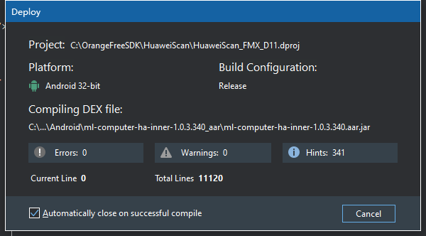
我们看下是什么命令让它卡住的：
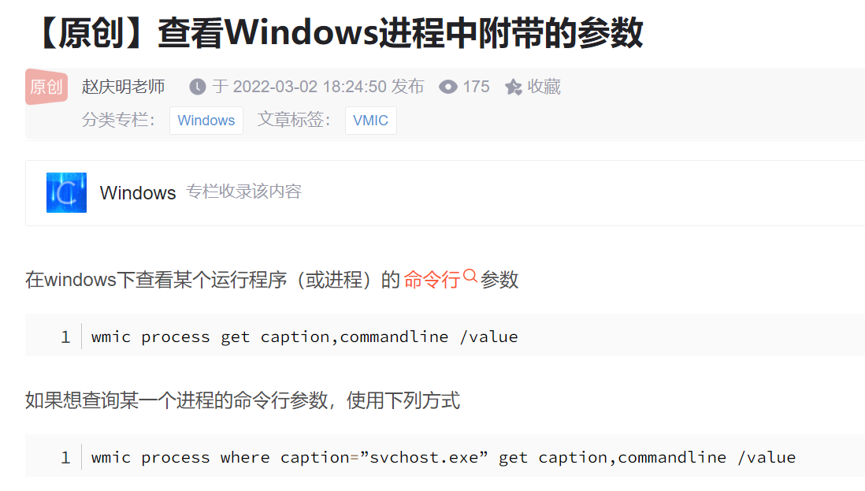
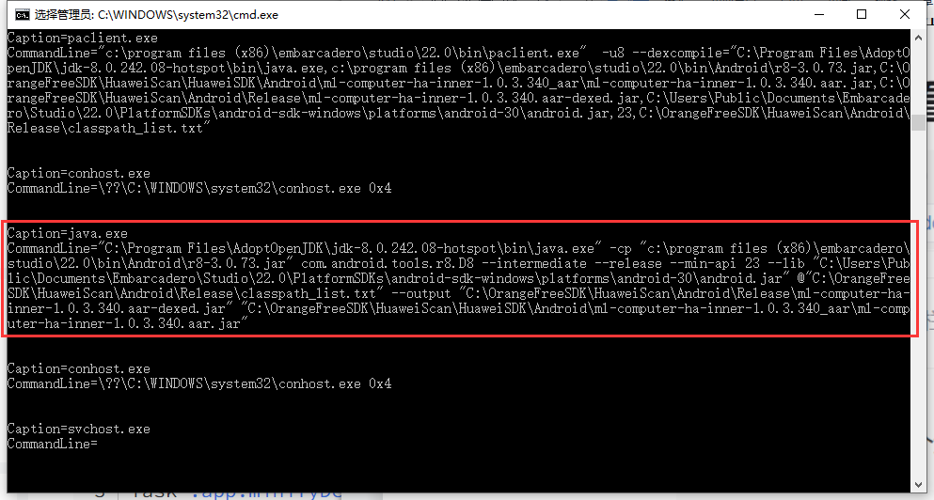
Caption=java.exe
CommandLine="C:\Program Files\AdoptOpenJDK\jdk-8.0.242.08-hotspot\bin\java.exe" -cp "c:\program files (x86)\embarcadero\studio\22.0\bin\Android\r8-3.0.73.jar" com.android.tools.r8.D8 --intermediate --release --min-api 23 --lib "C:\Users\Public\Documents\Embarcadero\Studio\22.0\PlatformSDKs\android-sdk-windows\platforms\android-30\android.jar" @"C:\OrangeFreeSDK\HuaweiScan\Android\Release\classpath_list.txt" --output "C:\OrangeFreeSDK\HuaweiScan\Android\Release\ml-computer-ha-inner-1.0.3.340.aar-dexed.jar" "C:\OrangeFreeSDK\HuaweiScan\HuaweiSDK\Android\ml-computer-ha-inner-1.0.3.340_aar\ml-computer-ha-inner-1.0.3.340.aar.jar"
在命令行中执行一下：
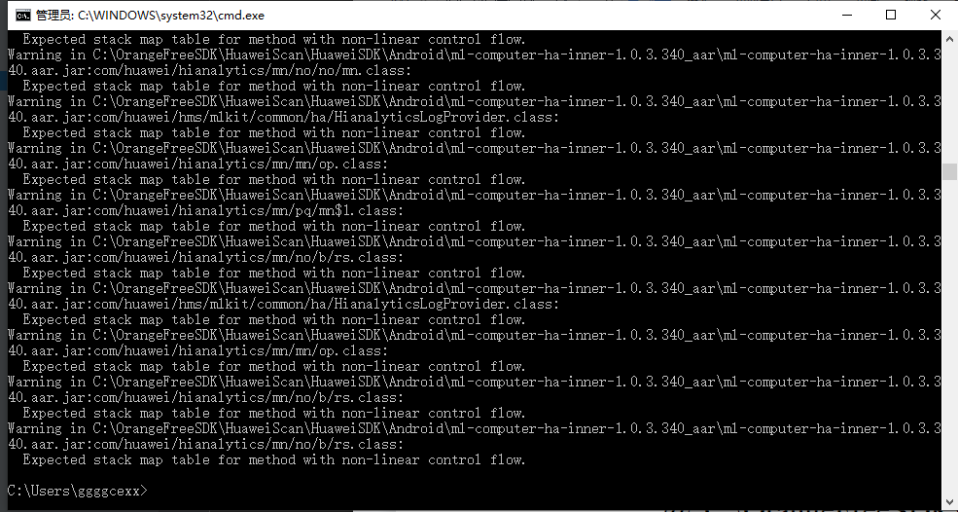
但是这些只是warnning，不应该卡死在这里，
报的警告是：Expected stack map table for method with non-linear control flow.
https://blog.csdn.net/zhukui66/article/details/122860044

又或者是JDK太老了，
升级为JDK 18，
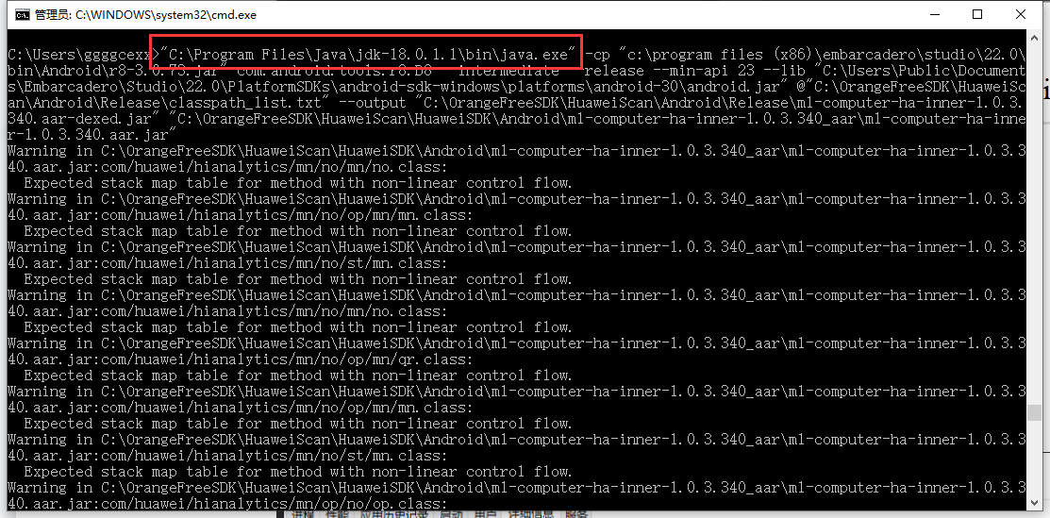
还是不行，

杀掉这个进程：
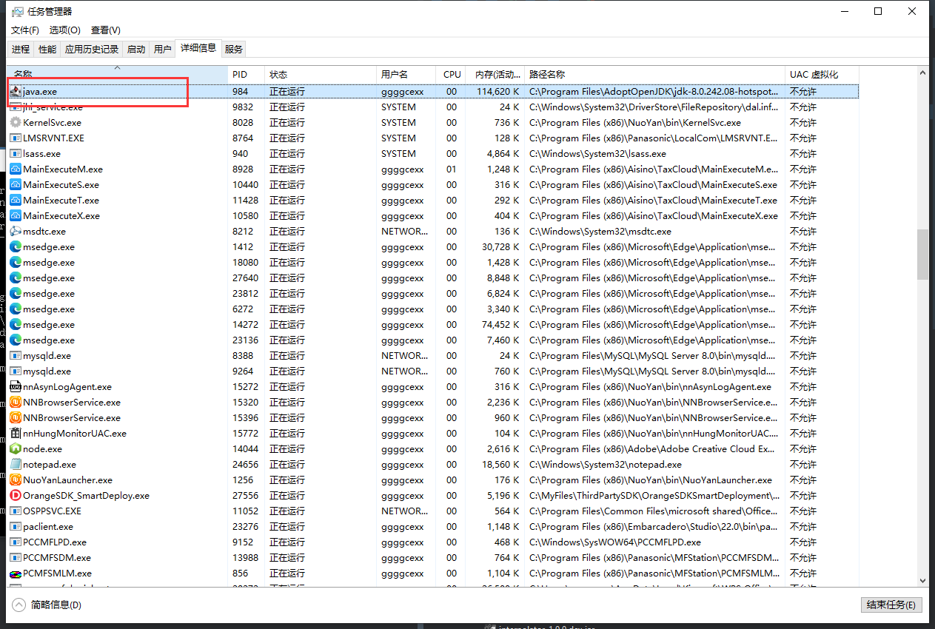

wmic process where caption="java.exe" get caption,commandline /value

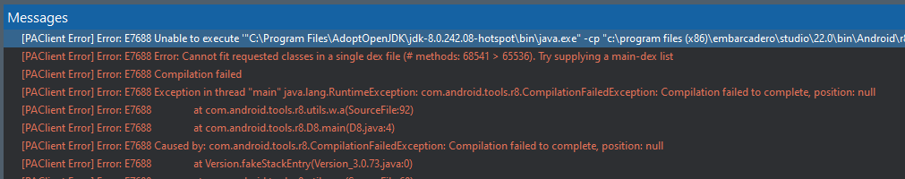
jar需要revert to system default
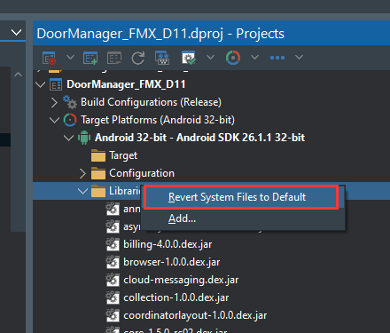
R.jar需要删除并用三方SDK智能布署目录重新生成：
